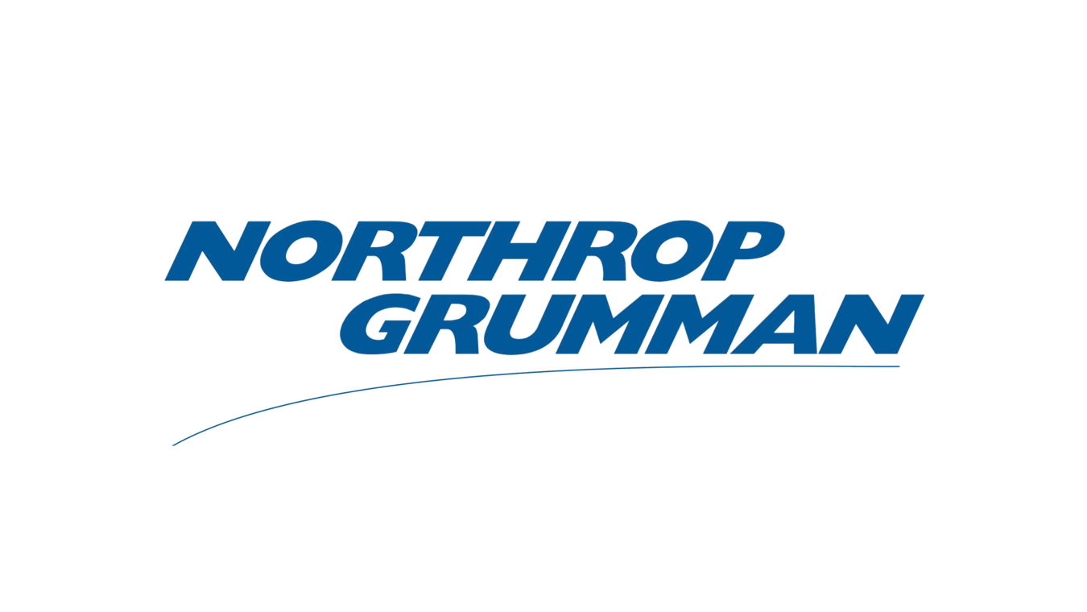

**INTERVIEW WORKSHOP**

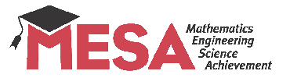

Facilitated by

Electrical and Computer Engineering, Computer Science majors

Bring resumes, Dress business casual

Register at https://goo.gl/forms/VZPf2RXYyzlYis3x2

**Room: Music 207**

**Wednesday, April 18, 2018**

**1:00-2:10 pm Resume Workshop**

**2:15-3:30 pm Interview Workshop**